General
- League night matches will be held at The Met Pool Hall @ 7p on Thursdays
  - A league night can be cancelled for:
    - Holiday/break
    - General busyness of EcoCAR
    - Not enough RSVPs for a week
- If members plan to attend a week’s league night, they must fill out that week’s RSVP form
  - RSVP will be sent out on Mondays before a week’s league night and due on Tuesdays @ 11:59p before league night
  - If you’ve RSVP’d, and find out you can’t go, you must inform Homer Butcher or Dalton Wiggins of the change
- There will be a required buy-in for each league night, strictly for paying for the night’s pool tables
  - Buy-in amount is subject to change week-by-week depending on RSVPs
  - Venmo Homer Butcher https://www.venmo.com/u/homerbutcher (@homerbutcher) OR bring cash (Venmo is preferred)
    - Members can pay either when you RSVP or when one arrives at The Met
    - Members will need to find Homer when you arrive to check if you’ve paid your buy-in before you play
- Matches will be 2 v 2 8-ball
  - Random partners week-by-week
    - IF there is an odd number of participants in a given week, a first come first serve final RSVP will be open until filled
      - Otherwise, there will be one lone wolf player for the week, they will play normally without switching between a partner.
  - Partners and matches announced on Wednesday before a week’s league night

Rules
- Once object balls have been racked, breaking team determined, and the break shot has been carried out, the table is open
  - If a ball was made off the break, the breaking team/player shall shoot again, otherwise it is the other team’s turn
  - If the 8-ball is pocketed off the break, the breaking team wins the game with 17 points
- After a team makes the first ball after the break, said team will take on the group balls the pocketed ball took and the other team will have the other group balls
- A team will continue to shoot until they fail to pocket a ball from their group, after which the other team will begin shooting
- After a team has made all of their group balls, they must pocket the 8 ball to win the game
  - The pocket that the 8-ball goes into must be called by the shooting team in order to win
- Have fun😀

Racking and Breaking
- When racking follow this pattern of solids and stripes:
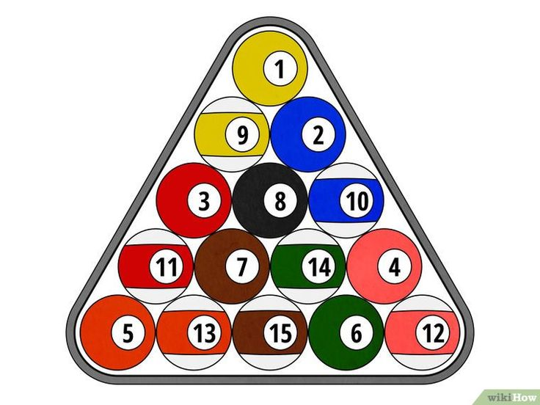
- To determine who racks and breaks, one player from each team will grab a ball each. On one end of table, shoot towards opposite rail, the ball that is closest to the shooting rail is the team to break and the other team will rack.
- To have a valid break, 4 balls must bounce off the rails
  - If not, rerack and rebreak
  - If scratch on break, break then goes to opposing team

Scoring
- All balls are worth 1 point, except for the 8 ball being worth 3 points
- A total of 17 points total is possible for a game
  - A maximum a single team can score is 10 points
    - If golden break is carried out (8-ball pocketed on break), 17 points to breaking team
- If a team makes an 8 ball out of order, a full 10 points is awarded to the opposing team and the offending team receiving points for balls potted up to the offense

Fouls
Any foul results in a ball in hand behind the second dots opposite the break side, group balls within area cannot be directly shot at (can bank off rails not contained in area), see figure below:
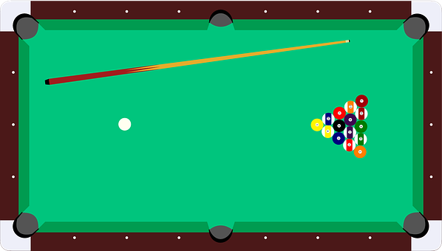
- Scratches
  - If a team makes the cue ball in a pocket during turn
  - If a team drives any ball off the table
    - If object ball, place either in front of closest pocket or point of exit
    - If cue ball, opponent’s turn
  - If the first object ball contacted by the cue ball is not a numbered ball from the shooter’s established group
  - A team can avoid a scratch without hitting any object balls if the cue ball contacts 3 unique rails
- General Play
  - Player must have one foot on ground during shot
  - Shooting while any ball is moving
  - If cue ball is struck in an accidental manner
  - To touch an object ball, in any way, while placing or shooting the cue ball
  - Non-shooting team (including teammates), cannot disturb, make noises, move around, cause distraction in any way
  - Marking the table in any way that could provide a player with an advantage in executing a shot
  - Any combination shot (using one object ball to pocket a different object ball) must be called
  - Both teams are responsible for watching and calling for any aforementioned fouls and play rules

